j


Student Name: Sara Mehrem
Student ID: 21110331
Section Number: 2

Database Design and Development
Mid Assignment

Contents
Database Requirement 3
Scenario 3
Data Requirements 3
User and System Requirement 4
Database Design 4
Conceptual Design 4
4
Mapping and Schema 5
Normalization 6
1st NF: 6
2nd NF: 7
3rd NF: 8
Logical Design 9
Physical Design 10
Effectiveness of The Design 11
Data Requirement 11
User Requirements 11
Conceptual Design 11
The entities and relationships: 11
Logical Design 12
Define the attributes for each entity 12
Mapping 12
Normalization 14
Logical design 14
Physical design 15
Employee Table 15
Flight Table 15
Airplane Table 16
Passenger Table 16
Flight_booking Table 16
Address Table 17
Why should I do all these steps! 17
Why the airport system is useful! 17
To user and system requirements 17

Database Requirement

Scenario
Sky International Airport, it is a big, modern and efficient airport in Jordan, Amman. It is a well-known airport on the world level, it contains several buildings, multiple terminals, waiting areas, tarmac, series of gates and everything an efficient airport needs, Everyday hundreds of planes fly to and land in, so there are thousands of passengers arriving and departing from it of the all nationalities. The airport has a good reputation and it has a high global rating.
The last time of developed the database system that is long time ago. These days, the airport management decides to design and develop more efficient database system to keep up the good reputation, the high rating and good serve to the passengers.
This airport system consists information about the passengers, airplanes, flight bookings, flights and the employees who are responsible for creating the flights and put details on it. Each flight is created by one employee while each employee can create many flights, as well as, each airplane has multiple flights and the flight belongs to one airplane.
Each flight can have many flight bookings, but the flight booking can only belong to one flight. The passenger can book one or more flight bookings, and the booking for one passenger.

Data Requirements
This airport system consists information about the passengers, airplanes, flight bookings, flights and employees.
- Each employee is responsible to create at least one flight and its details, and each flight can be created only by one employee. And each employee has an employee ID, first name, last name, work email, password, salary, and only one phone number.

- Each airplane has multiple flights, and the flight can be only belonged to one airplane, and each airplane has an airplane ID, airplane model, capacity, and status.

- Each flight has a multiple flight booking, while the flight booking can belong to one flight. Each flight has a flight number, destination, date, specific time. Each flight booking has a passenger SSN, and the flight number.

- Each passenger can book multiple flight booking, and the flight booking belongs to multiple passengers. Each passenger has passenger SSN, one email, password, first name, last name, and addresses.

User and System Requirement
There is below the user and system requirement
- Employees
The expected transactions from the employees, each employee can access/login to his/her account, add the flights and its details, view and delete flights.

- Passengers
Each passenger can signup/create an account, login, add, update bookings, and view flights.

Database Design

Conceptual Design
The conceptual design is the first step of the database design which is, to define the entities, the relationships and give a name for each relationship between them, to make the clear.

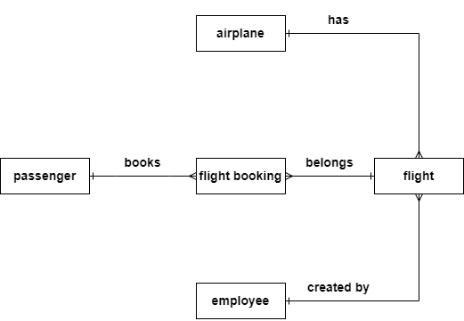

Mapping and Schema
There is the schema after mapping
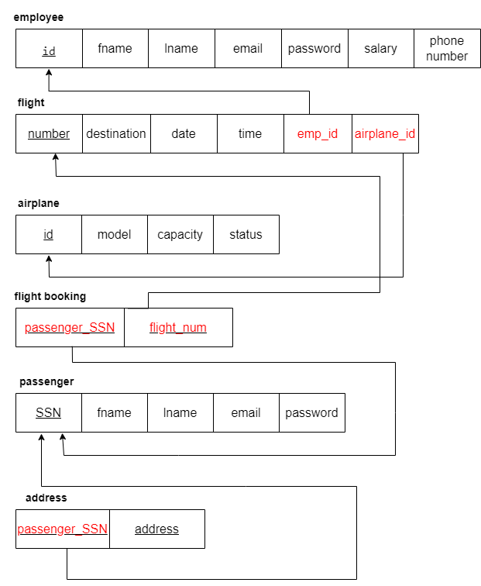

Normalization
The schema that is appeared, that is no need to normalize it, all of relations in the 3rd normal form, so no need to normalize it, because no redundancy that might effect on the transaction will be happened. Because of the correct mapping the schema doesn’t need to normalize any relation, correctly mapping.
So, there are some examples on each normal form.

1st NF:
The 1st normal form which say: to be in the 1st normal form the relation should divide the composite attribute to multiple attributes, and the multi-value attribute put in on new relation with the primary key (that is on the original relation) as a foreign key and primary key.
An examples:

Relations | Attributes | Violation Description | Solution – Relations
The relations schema | The attribute name | Describe why it is not in the 1st NF (the violation) | Show the schema for each affected relation.
Employee | id, name, salary | Because there is a composite attribute | Employee(id, fname, lname, salary)
passenger | SSN, fname, lname, address | Because there is a multi-value attribute | Passenger(SSN, fname, lname)  Address(passenger_SSN, address)

2nd NF:
The 2nd normal form which say: to be in 2nd normal form, the relation should be in 1st NF, and the all attributes should depend/determine on the all primary key, in other words, if there is no partial dependency, so the relation will be on the 2nd NF.
An examples:
Relations | FDs | Violation Description | Solution – Relations
The relations schema | Show the functional dependencies causing the violation | Describe why it is not in the 2nd NF (the violation) | Show the schema for each affected relation.
Passenger_booking(  P_SSN, fname, lname, booking_id, ticket) | The attribute (P_SSN (PK)) determine the attributes (fname, lname) and the attribute (booking_id (PK)) determine the attribute (ticket) | Because there is a partial dependency | Passenger(p_SSN, fname, lname)  Booking(booking_id, ticket)  Passenger_booking(p_SSN, booking_id)
Flight_airplane(flight_num, destination, date, airplane_id, model, capacity) | The attributes (destination, date) depend on the attribute (flight_num (PK)) and the attributes (model, capacity) depend on the attribute (airplane_id (PK)) | Because there is a partial dependency | Flight(flight_num, destination, date)  Airplane(airplane_id, model, capacity)  Flight_airplane(flight_num, airplane_id)

3rd NF:
The 3rd normal form which say: to be in 3rd normal form the relation should be in the 2nd normal form and no transitive dependency, the transitive dependency: if a non-prime attribute depends on the non-prime attribute and one of them depend on the primary key.
An examples:
Relations | FDs | Violation Description | Solution – Relations
The relations schema | Show the functional dependencies causing the violation | Describe why it is not in the 3rd NF (the violation) | Show the schema for each affected relation.
Passenger(SSN, area code, country) | The attribute (passenger_id (PK)) determine the attribute (country (non-prime attribute)) and the attribute (country (non-prime attribute)) determine the attribute (area code (non-prime attribute))  SSN -> country / country -> area code and SSN -> area code | Because there is a transitive dependency | Passenger(passenger_id, area code)  Info(area code, country)
Flight(flight_id, airplane_id, seats number) | Flight_id -> airplane_id -> seats number and flight -> seats number | Because there is a transitive dependency | Flight(flight_id, airplane_id)  Airplane(airplane_id, seats number)

Logical Design
A logical design is a design that is defines and makes clear the relations, attributes, relationships, weak and strong entities, PKs and FKs.

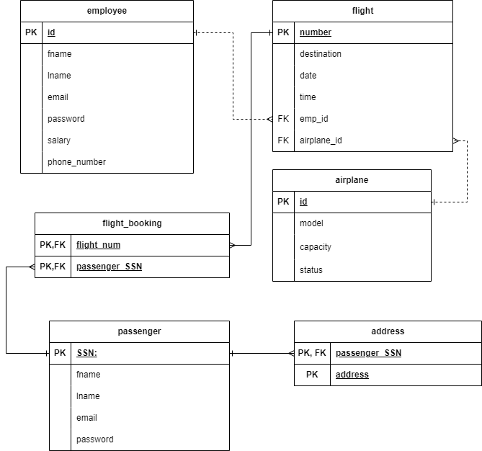

Physical Design
the physical design is like the logical design but it shows the data type for each attribute and adding constraints if needed. Below is the physical of the airport database system.
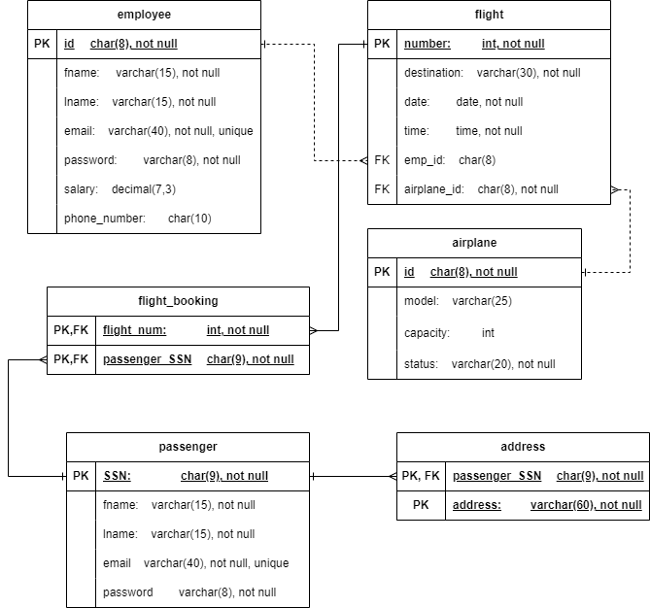

Effectiveness of The Design
Each step of database design process, serves a specific benefit and purpose to full efficiency of the airport database system.
Below, the useful for each step.

Data Requirement
This step helps to understand and analyze the data that is needed to the database, well-understanding the data requirements supports the necessary operations/functionalities.
By identify the entities, relationships, and attributes in the above airport data requirements, the database system design becomes clear and align with the user needs and requirements.

User Requirements
Identify the airport system's users and what the expected abstraction on the database system by GUIs, is a very important step, because there are a different users and different roles, such as there are employees (users), and they are expected to: log in, add the flights and flight details, view and delete flights (roles), on other side, there are passengers (users), and they are expected to: signup/login, add, update bookings, and view flights. So, when the user requirements are cleared like the above ones, this leads to design an efficient database works efficiently as expected requirements. So, there is expected to good user experience.

Conceptual Design
Define the entities (employee, flight, flight booking, airplane, passenger) and the relationships between them, by this design, it is clear to see the abstract representation and the structure without the implementation details of the database system.
This design provides and helps me to contain the base of the database design and imagine how the next step would be. Mainly, the conceptual design is the base of the database design, it ensures the well-understand of the structure easily before going to the logical design.
By defining the entities (employee, flight, airplane, flight booking, passenger) and relationships based on the scenario and data requirements because it is needed to build the base step correctly to build the next steps correctly too. Airport conceptual design is so important for realizing the entities and relationships and understanding it.

The entities and relationships:
Employee and flight entities with 1:M relationship: the employee entity represents the employees who are responsible to create a flights, and the flight entity represents the flights that are created by employees. The relationship between these two entities is one to many (1:M) because each employee can create many flights but the flight can be created by one employee, so it logic this relationship to be in this type.
airplane and flight entities with 1:M relationship: the flight entity represents the flights that are created, and the airplane entity represents the airplanes for flights. The relationship between these two entities is one to many (1:M) because each airplane has a many flights but each flight belongs to one airplane, that’s why the relationship is one to many.

Flight and flight booking entities with 1:M relationship: the flight entity represents the flights that are created, and the flight booking entity represents the booking by passengers for the flights. The relationship between these two entities is one to many (1:M) because each flight has many bookings by passengers but the multi-bookings belongs to one flight. The relationship between flight and flight booking is one to many (1:M) because each flight contains many bookings while the booking belongs to one flight.
Passenger and flight booking entities with 1:M relationship: the flight booking entity represents the booking by passengers for the flights, and the passenger represents the passengers that they will book for flights. The relationship between them is one to many because each passenger can book multiple bookings but the bookings belong to a specific passenger.

Logical Design
This design (consists the mapping and schema, normalization, and the drawn the design) between the structure/abstraction design and the implementation. In logical design, based on conceptual design and the airport data requirement, logical design is the foundation of the database structure.
Mapping and schema, define the PK and FK to link the relations with each other by relationships, and define the attributes.
Normalization, because correctly mapping, and it is a small system, no need to normalize any relation to reduce the data redundancy in the database.
Logical design, is like an imagination of how data will be stored and organized.
Define the attributes for each entity
- Each employee has (employee ID, name, work email, password, salary, phone number).

- Each airplane has (airplane ID, airplane model, capacity, status).

- Each flight has (flight number, destination, date, specific time).

- Each flight booking has (passenger SSN, flight number).

- Each passenger has (passenger SSN, first name, last name, addresses, email, password).

Mapping
- Mapping of regular entities
Write the regular entities (not weak entities) which are (airplane, flight, employee, and passenger) because each one of them depends on its own primary key. So, determine the primary key for each entity, so all the attributes depend on it in the relation because the value of the primary key must not be repeated.

  - On the employee relation, the attribute (employee id) the most suitable to be the primary key of this relation. Because the other candidate attributes (email and phone number), each one of them is not suitable to determine the other attributes, also is not logic to determine the employee by the phone number or the email.

  - On the airplane relation, only the attribute (airplane id) can determine the airplane/determine the other attributes, because no other candidate attributes can be options. the (airplane id) attribute is the most suitable and only one could be the primary key, so the airplane id is the primary key.

  - On the flight relation, the (flight number) attribute only one can determine the flight relation, it is the only candidate key, so the flight number is the primary key.

  - On the passenger relation, the suitable attribute to be the primary key is the passenger SSN, the candidate keys are email and SSN, but the suitable and logic option is the passenger SSN, so the passenger SSN is the primary key.

- Mapping of the composite attributes
Doing mapping to the composite attribute, the first normal form in normalization, unpack the composite attribute, so each piece of the attribute should store in its own column. In employee relation unpack the attribute name to first name attribute and last name attribute to be more organized. So the data will be organized in the database.

- Mapping of the derived attribute
There are no derived attributes in the airport system according to the data requirements.

- Mapping of multi-value attributes
In the passenger relation, the multi-value attribute (address), put the address on the new relation and put the passenger SSN and the address as a composite primary key and the passenger SSN also as a FK.
The composite primary key {passenger_SSN, address} because the two attributes together will never repeat the same values. Doing this step to eliminate the duplicated data, also, because simply abstractions and simplify the database design.

- Mapping of weak entity
The flight_booking entity is a weak entity because it depends on the passenger_SSN attribute and flight_number attribute as a composite primary key and each attribute is a FK from the original relation. Putting the composite primary key to eliminate the duplicated data, after that the duplicated data if it is happened, the user cannot be able to do his/her functionality.

- Mapping of 1:1 relationship
There are no 1:1 relationship in the design.

- Mapping of 1:M relationship
- Employee and flight, 1:M
take the PK (emp_id) from the employee relation, and also put it as a FK in the flight relation in a dotted line (strong entities). This step because it is needed to connect these two entities together.

- Airplane and flight, 1:M
Take the PK (airplane_id) from the airplane relation, and also put it as a FK in the flight relation in dotted line (strong entities). This step because it is needed to connect these two entities together.

- Flight and flight_booking, 1:M
take the PK (flight_num) from the flight relation, and also put it as a FK and PK in the flight_booking relation in a solid line (strong entity (flight) and weak entity (flight_booking)). This step because it is needed to connect these two entities together.

- Passenger and flight_booking, 1:M
take the PK (passenger_SSN) from the passenger relation, and also put it as a FK and PK in the flight_booking relation in a solid line (strong entity (passenger) and weak entity (flight_booking)). This step because it is needed to connect these two entities together.

- Passenger and address, 1:M
take the PK (passenger_SSN) from the passenger relation, and also put it as a FK and PK in the address relation in a solid line (strong entity (passenger) and weak entity (address)). This step because it is needed to connect these two entities together.

Normalization
The normalization is very important step to get rid of any problem such as minimize the redundancy and dependency to improve the database design. So the users can do their functionalities efficiently.
Because of this airport system is simple and for good mapping, nothing of the design needs to normalize it, so almost of the relations normalized in the mapping.

Logical design
After all the previous steps, drawing the logical design (relations, strong/weak relations, attributes, relationships, PK, FK) for the airport system using draw.io to initial imagine the database system.

Physical design
the physical design will determine how the database will be implemented. It is look like the logical design but with the datatype for each attribute and add constraints on the airport system.

Employee Table
- Id with char(8) data type because the employee should input the 8 characters when log in and with (not null) constraint because it is a primary key.

- Fname with varchar(15) data type because the each employee has first name with different size of the characters but the maximum size is 15 characters, and with (not null) constraint because the employee should have a first name.

- Lname with varchar(15) data type because the each employee has a last name with different size of the characters but the maximum size is 15 characters, and with (not null) constraint because the employee should have a last name.

- Email with varchar(40) data type because each employee has a different size of the email when the employees input (log in) their accounts, and with (not null) constraint because the employee should have an email to log in, and unique constraint because each email should be different/unique.

- Each employee has a password to his email with varchar(8) data type, because the maximum character to the password in this system 8 character, with (not null) constraint, because each employee's email should has a password to it.

- Salary, each employee has a salary for his/her work, with salary(7,3) data type, so the total digits is 7 and the digits after the decimal point is 3.

- Phone number with char(10) data type, because the phone number is 10 digits/characters and should be stored 10 characters. And it's fine if its value is null.

Flight Table
- Flight_num with int data type, because simply it is a number, and with (not null) constraint because it is a primary key.

- Destination with varchar(30) data type, because the destination is a string/characters with different size for each destination, and the maximum size of characters is 30. With (not null) constraint because the destination for the flights should be existed.

- Date with date data type, and with (not null) constraint because the flight date should be existed.

- Time with time data type, and with (not null) constraint because the flight specific time should be existed.

- Emp_id with char(8) data type, and it should be no employee (null) if the employee leaves his/her job.
- Airplane_id with char(8) data type because the id for airplanes in this airport contains of exactly 8 characters, and with (not null) constraint because each flight has an airplane.

Airplane Table
- Airplane_id with char(8) data type because the id for airplanes in this airport contains of exactly 8 characters and with (not null) constraint because it is a primary key.

- Model with varchar(25) data type because there are many different of models and for each model, different size of character, so the maximum is 25 characters.

- Capacity with int data type, because it is a number.

- Status with varchar(20) data type, because the status is a characters and each status has a different size of characters, and the maximum characters are 20. With (not null) constraint the status should be existed to know the status for each airplane.

Passenger Table
- Passenger_SSN with char(9) data type because the SSN contains of 9 character and it should be input 9 characters. And with (not null) constraint because it is a primary key.

- Fname with varchar(15) data type because the each passenger has first name with different size of the characters but the maximum size is 15 characters, and with (not null) constraint because the passenger should have a first name.

- Lname with varchar(15) data type because the each passenger has a last name with different size of the characters but the maximum size is 15 characters, and with (not null) constraint because the passenger should have a last name.

- Email with varchar(40) data type because each passenger has a different size of the email when the passenger input (log in/sign up) their accounts, and with (not null) constraint because the passenger should have an email to log in/sign up, and unique constraint because each email should be different/unique.

- Each passenger has a password to his email with varchar(8) data type, because the maximum character to the password in this system 8 character, with (not null) constraint, because each passenger's email should has a password to it.

Flight_booking Table
- Flight_num with int data type, because simply it is a number, and with (not null) constraint because it is a primary key.

- Passenger_SSN with char(9) data type because the SSN contains of 9 character and it should be input 9 characters. And with (not null) constraint because it is a primary key.

Address Table
- Passenger_SSN with char(9) data type because the SSN contains of 9 character and it should be input 9 characters. And with (not null) constraint because it is a primary key.

- Address with varchar(60) data type, because each address has a difference with the size of characters, and the maximum size is 60 characters, And with (not null) constraint because it is a primary key.

Why should I do all these steps!
Starting sequentially with each step and design, so that the designs are integrated with the absence of errors that lead to duplication of data and so on.
Doing all these steps to the airport system because I want the system to be efficient with no duplicated data and for facilitate the data manipulation. Also for enhancing the data integrity and simplify designing the database.

Why the airport system is useful!
The airport system is useful because the all steps are followed step by step (understand the data requirements, consider the user requirement, conceptual design, logical design (mapping and normalization then draw it), physical design) to rule out the possible errors that can cause system problems (duplicated data, system malfunction, …) when users deal with the system.
The airport system is integrated so it excludes and reduces (minimize) the occurrence of errors.

To user and system requirements
While the airport system is integral with all aspects, the user will be able to perform the expected transaction easily without duplicated data, or any expected error, because all these steps that are that are implemented on the designs will minimize the problems, by the techniques those are followed to integrate the system.
The users will do the expected abstraction from them (add, remove, update and retrieve data) efficiency.
The system is expected to be well-implemented and efficiently, so that the user can deal with the system through user interfaces (UIs) with no problems in the system, so that the user performs the expected operations/transactions correctly and efficiently without any problems and errors.

